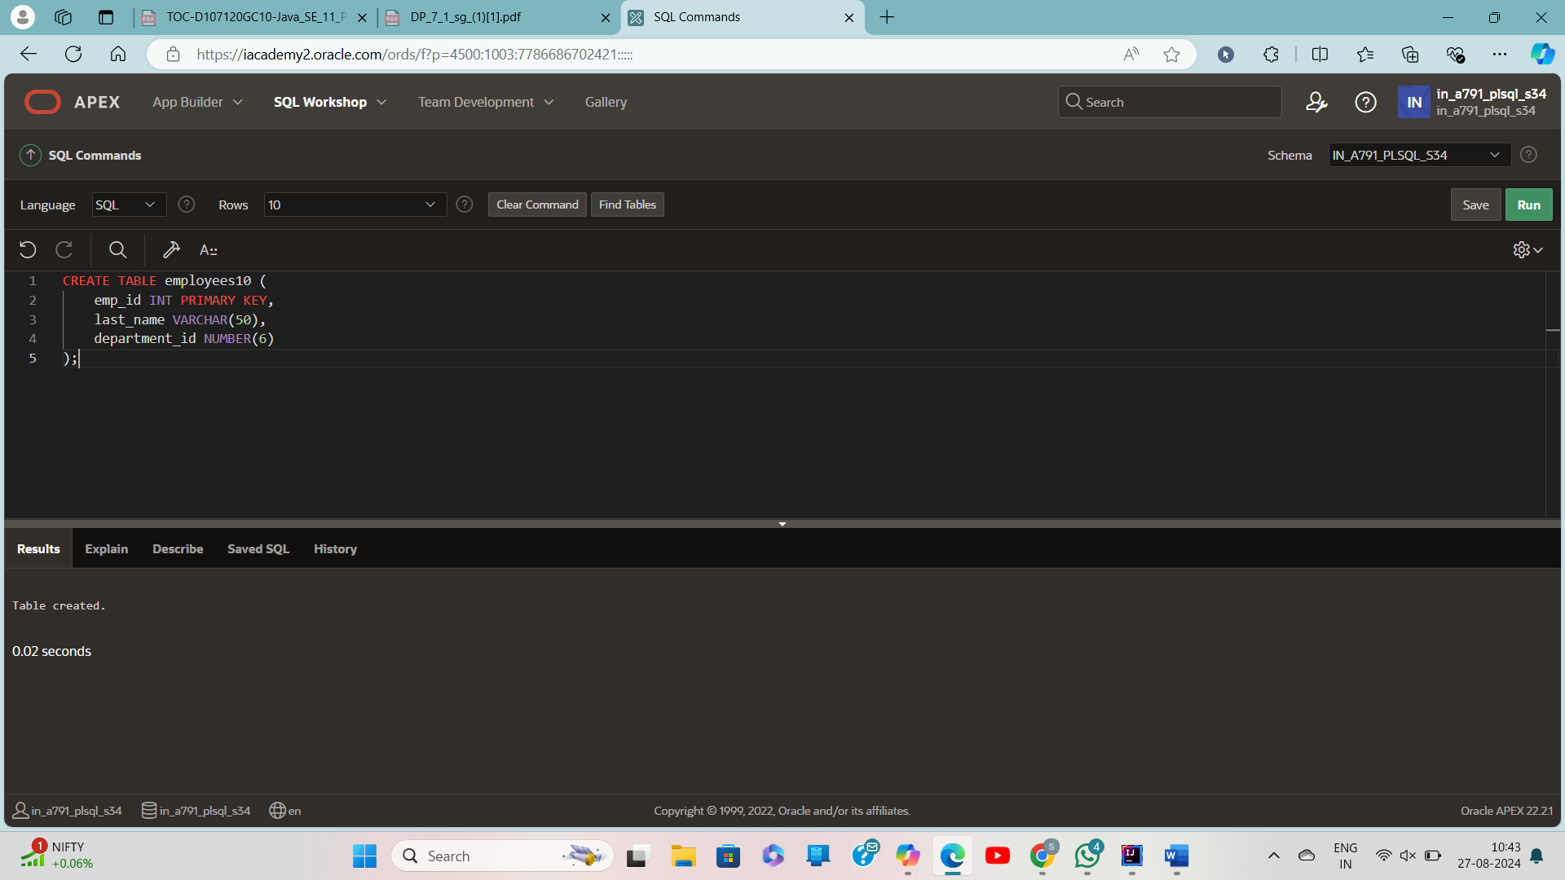

CREATE TABLE employees10 (

emp_id INT PRIMARY KEY,

last_name VARCHAR(50),

department_id NUMBER(6)

);

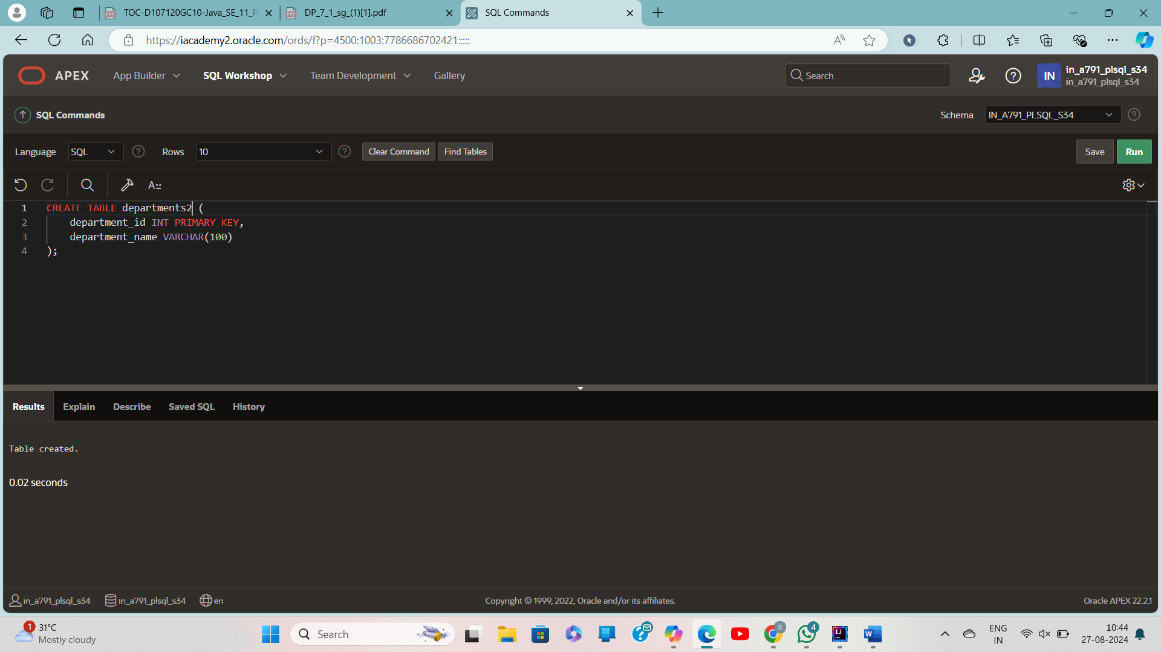

CREATE TABLE departments2 (

department_id INT PRIMARY KEY,

department_name VARCHAR(100)

);

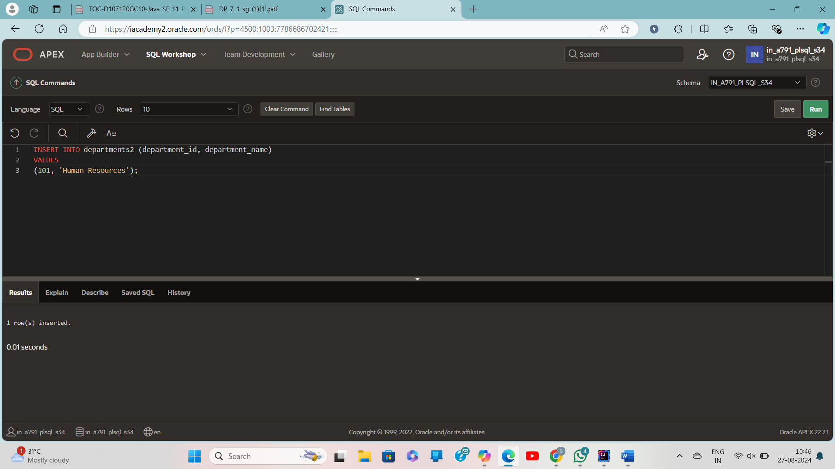

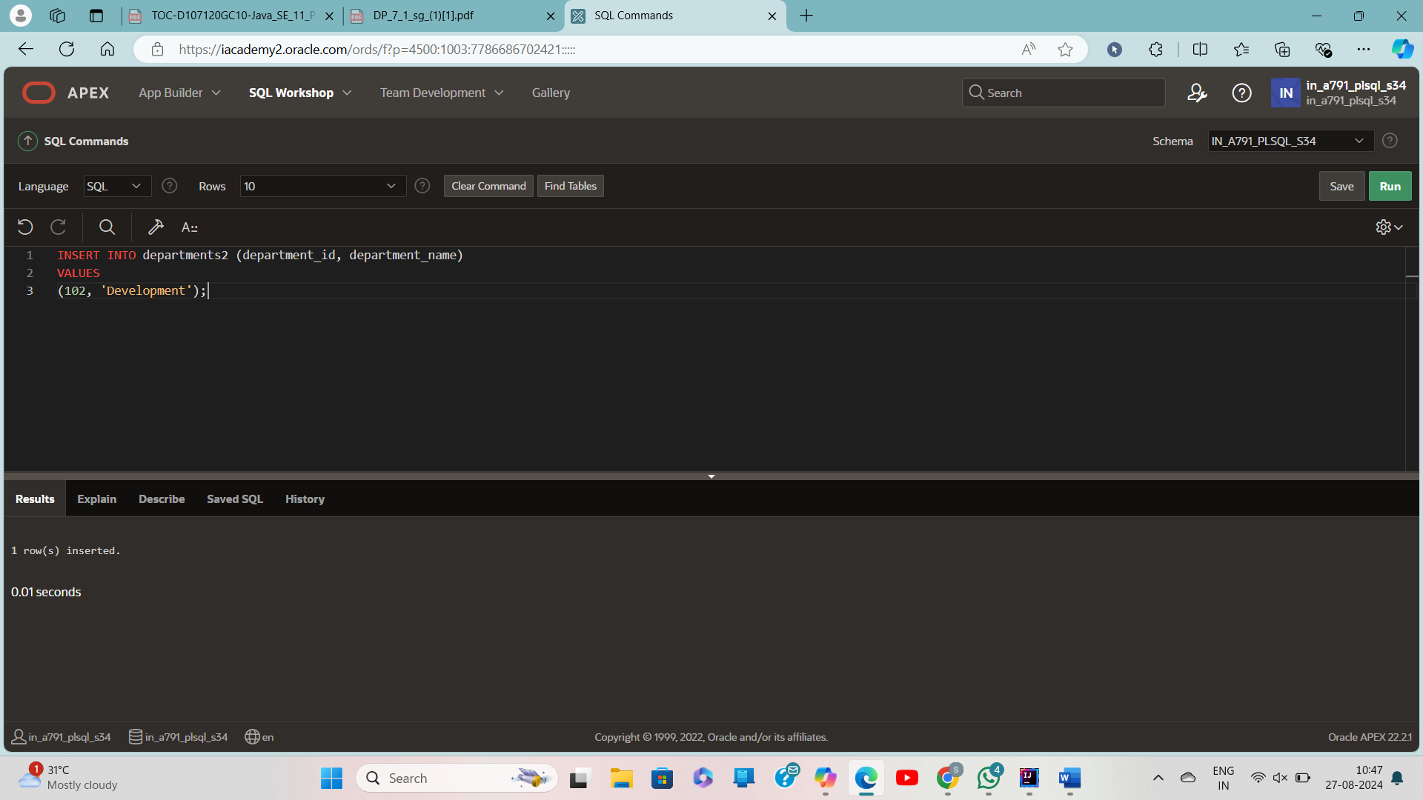

INSERT INTO departments2 (department_id, department_name) VALUES (101, 'Human Resources');

INSERT INTO departments2 (department_id, department_name) VALUES (102, 'Development');

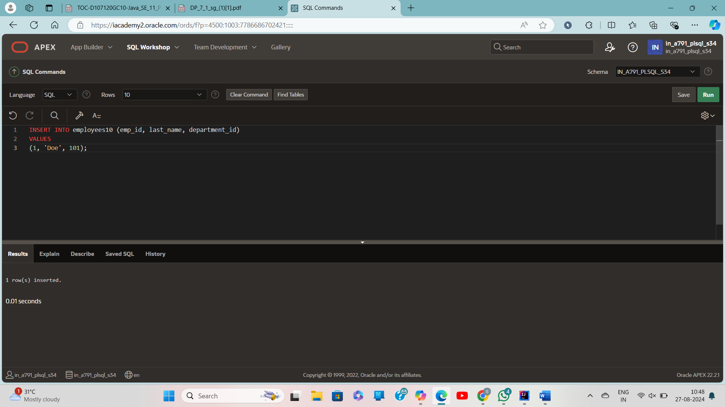

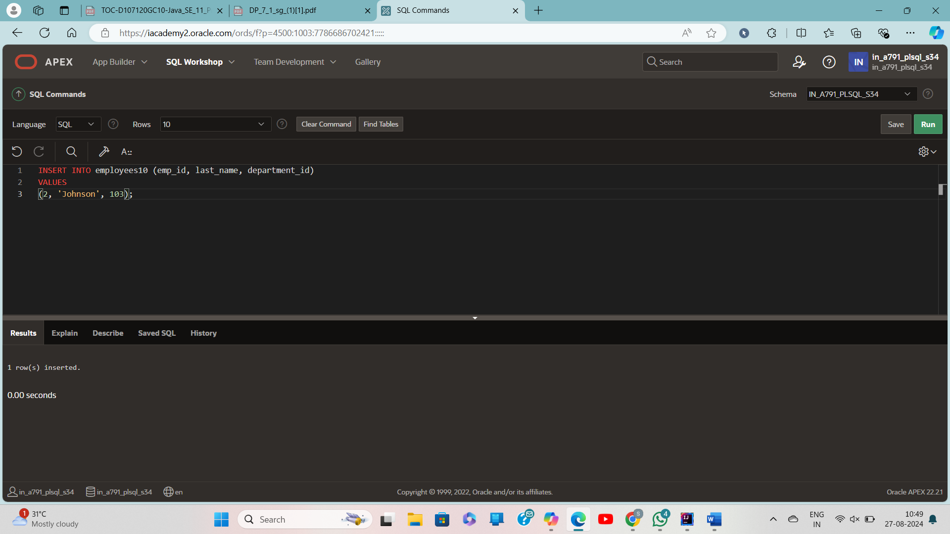

INSERT INTO employees10 (emp_id, last_name, department_id)

VALUES (1, 'Doe', 101);

INSERT INTO employees10 (emp_id, last_name, department_id)

VALUES (2, 'Johnson', 102);

SELECT e.last_name, e.department_id, d.department_name

FROM employees10 e

FULL OUTER JOIN departments2 d ON e.department_id = d.department_id

